F74092308 尤莙琇
1.
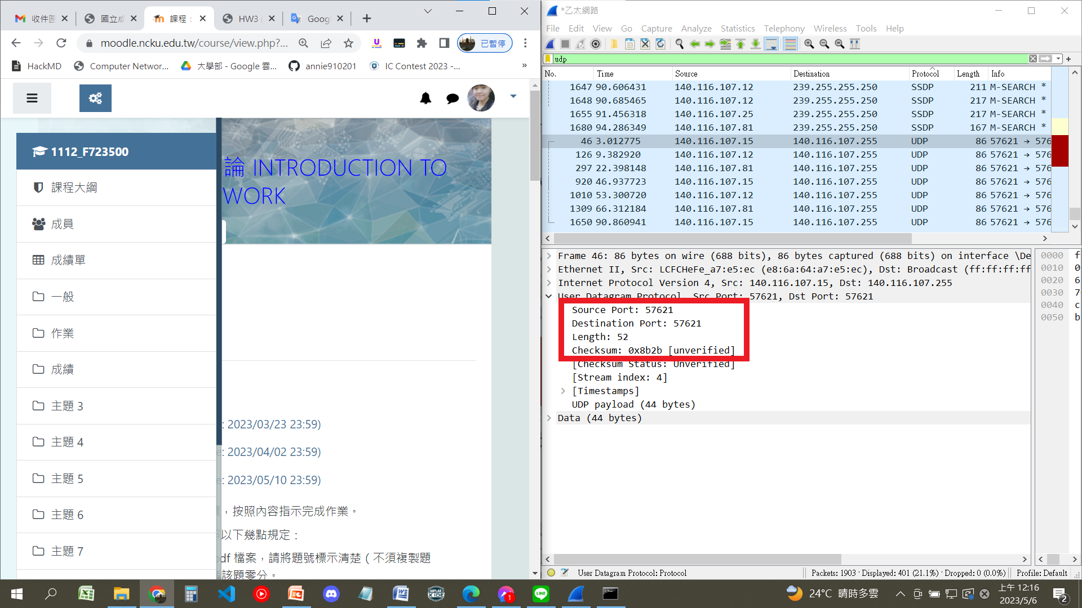
4 field( source port、destination port、length、checksum)
2.
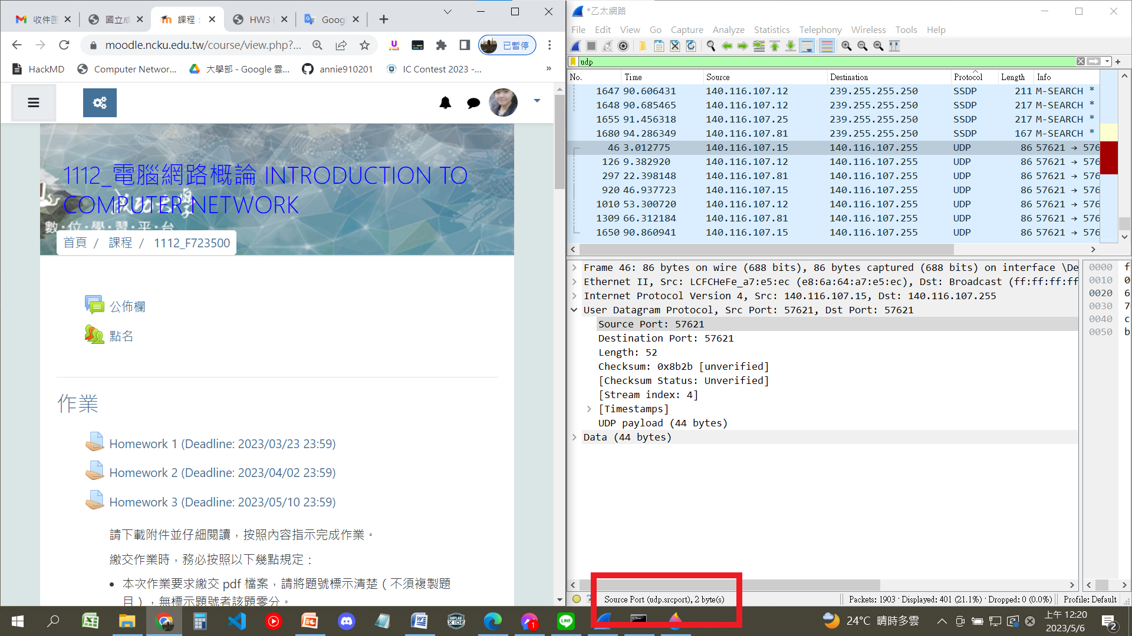
Source port: 2 bytes
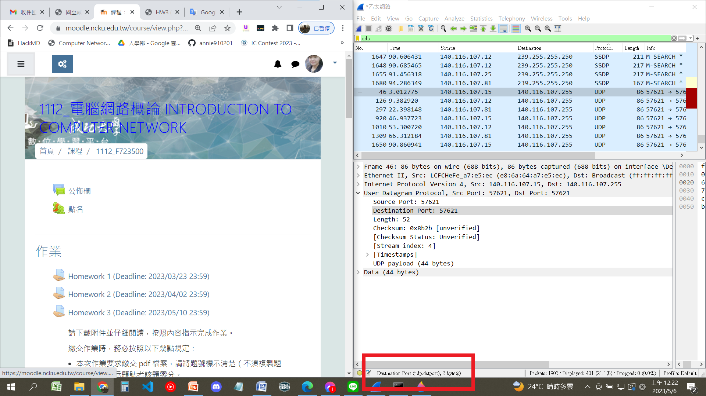Destination port: 2 bytes
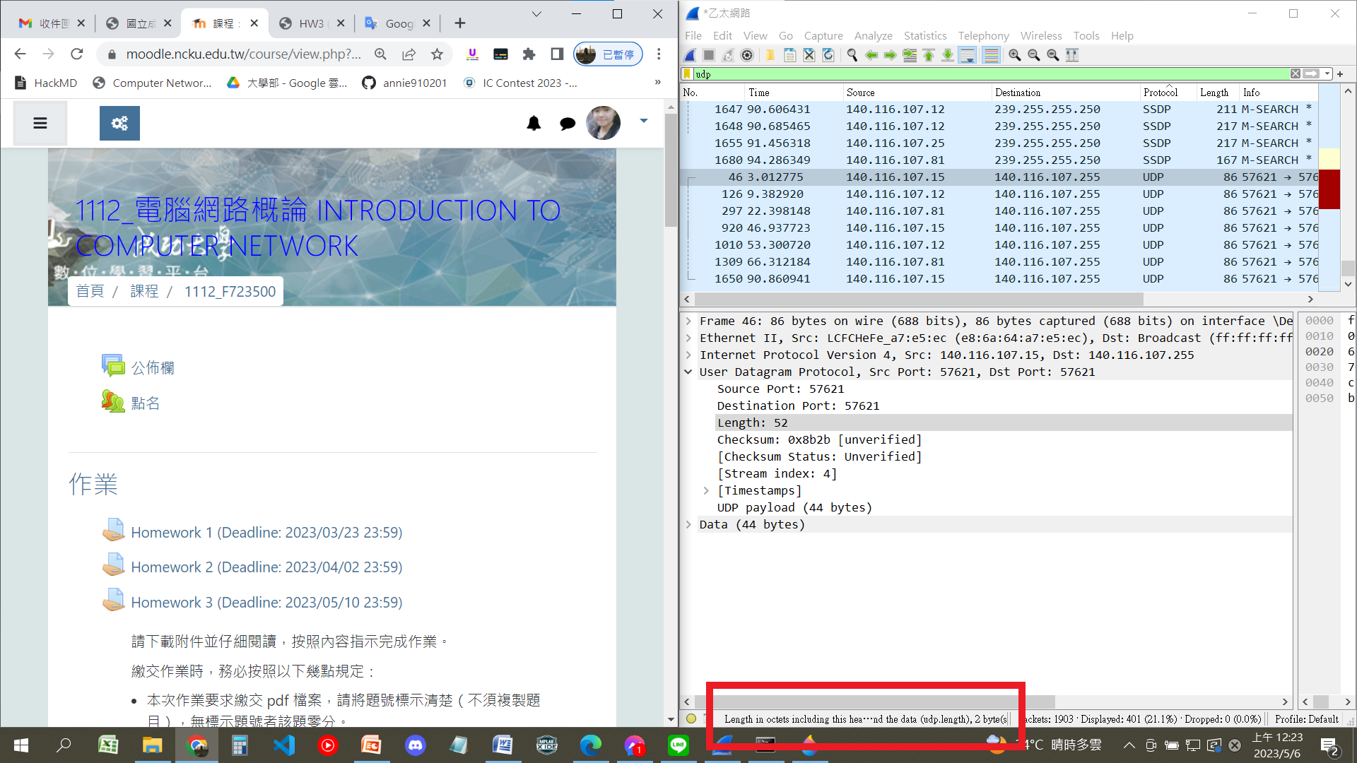
Length: 2 bytes
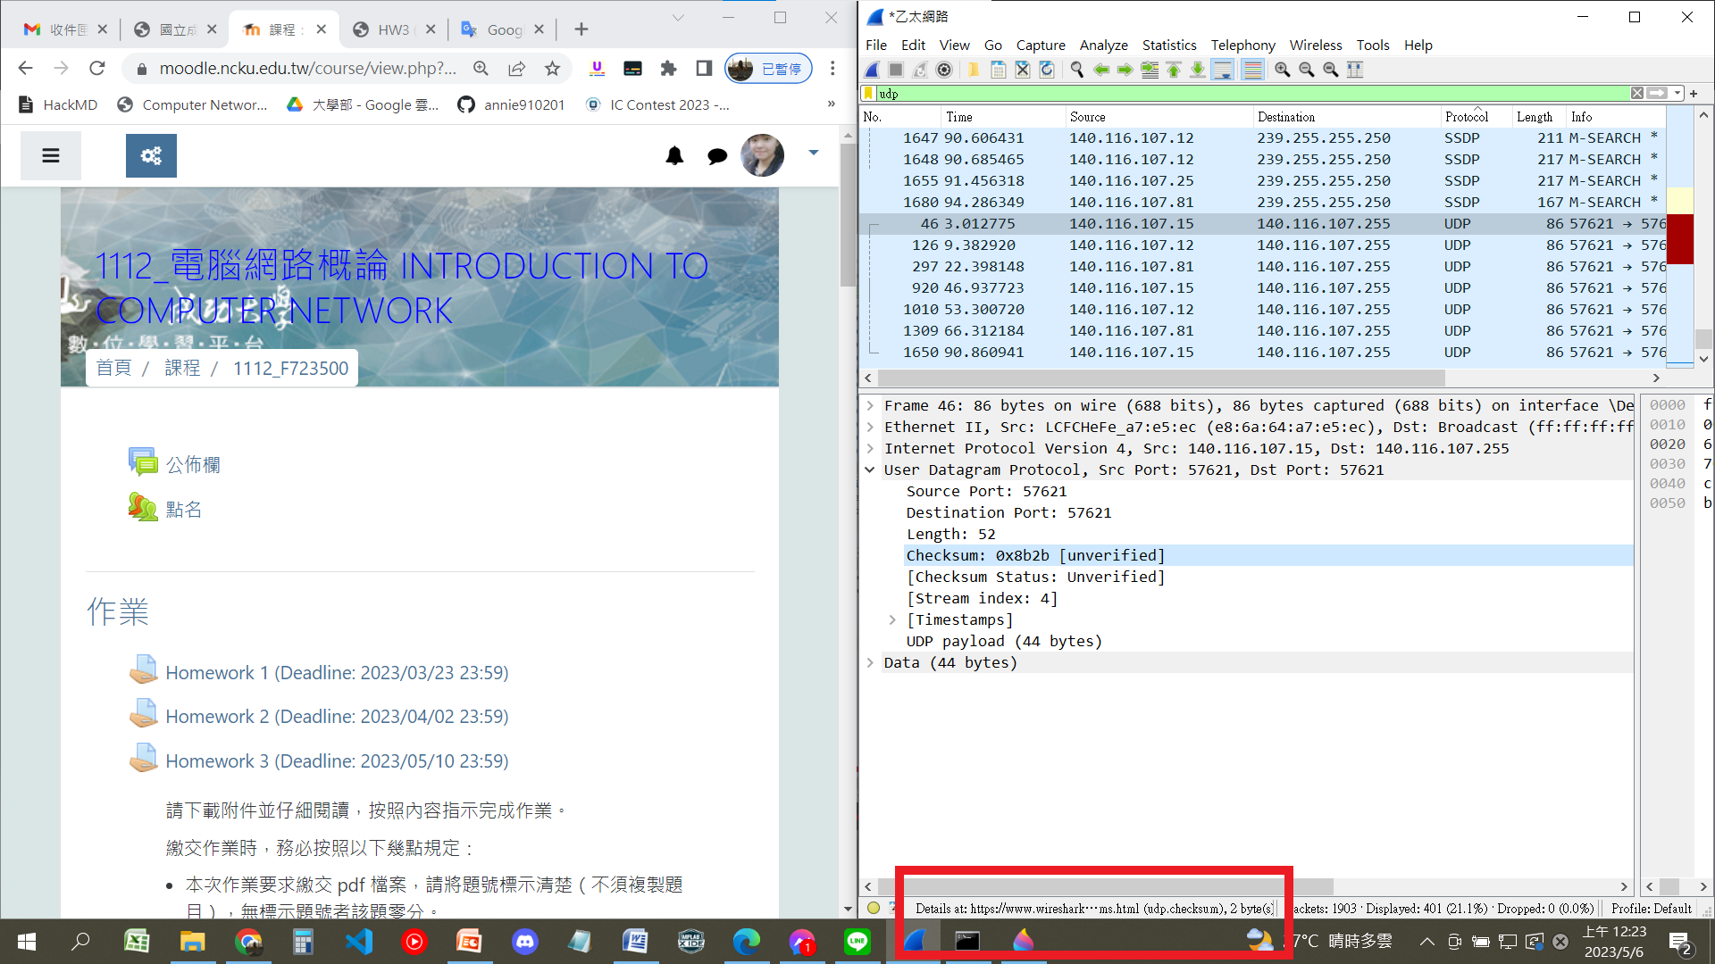
Checksum: 2 bytes
3.
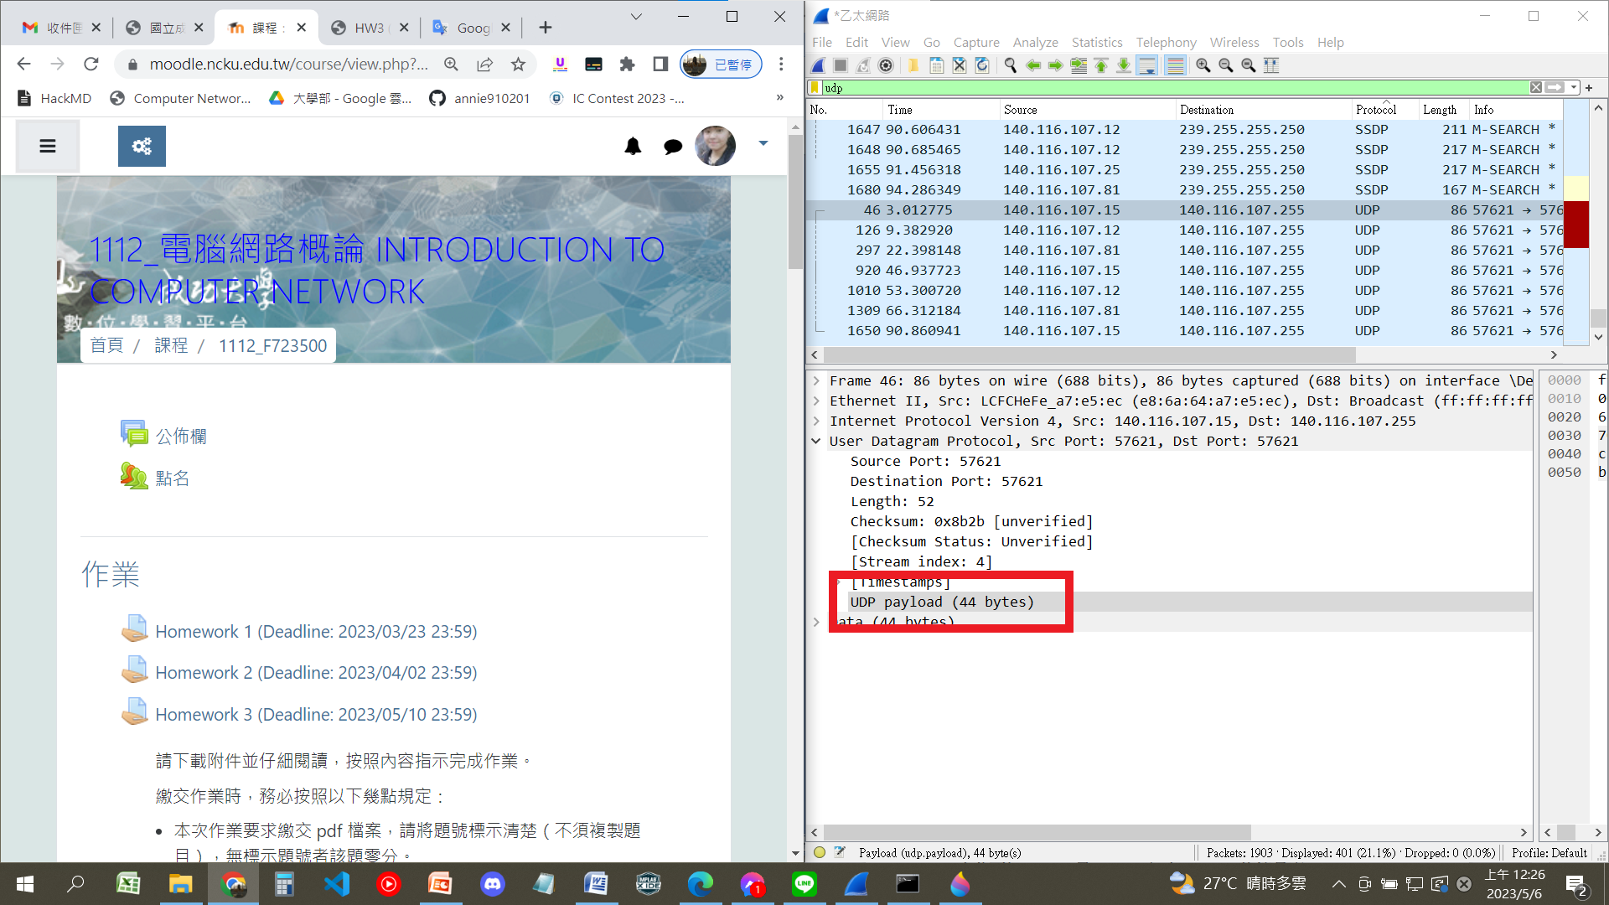
UDP packet 的payload是44 bytes，加上header也就是source port、destination port、length、checksum的2*4bytes一共是52bytes，剛好可以跟length的52對上
所以The value in the Length field is the length of header + payload
4.
由第二題，Length = 2 bytes，又1byte = 8bit，所以一共是16bits
2^16 – 1 = 65535
65535 – 8(header) = 65527
所以maximum number of bytes that can be included in a UDP payload = 65527 bytes
5.
由第二題，Source port = 2 bytes = 16bits
所以largest possible source port number = 2^16-1 = 65535
6.
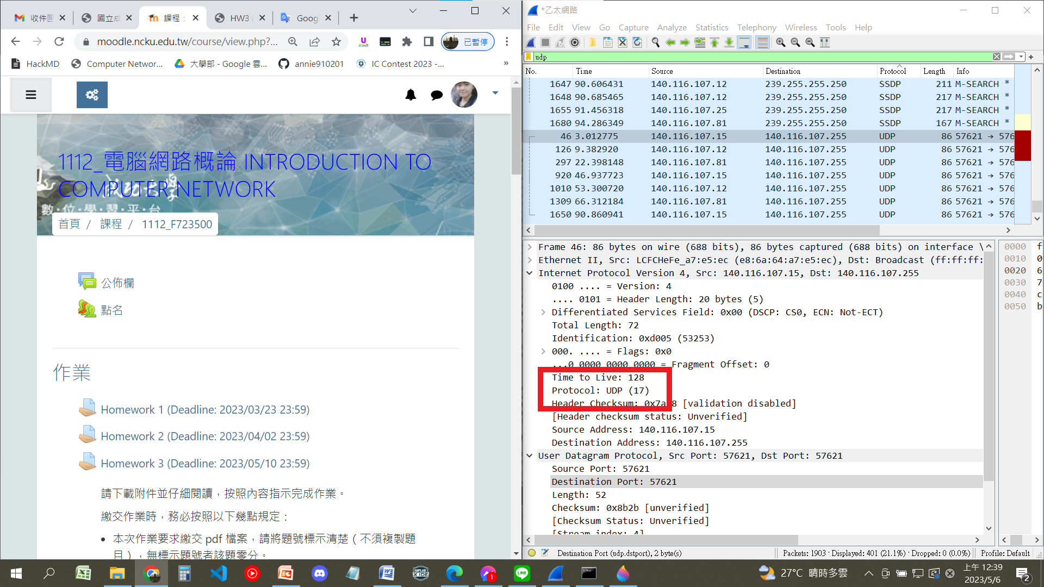
the protocol number for UDP = 17

